Visitor Policy

Policy:
Ehatare Retirement & Nursing Home has a responsibility to ensure residents receive visitors safely to help maintain a safe Home and to protect against the risk of COVID-19. This policy balances mitigating measures to protect the health and safety of residents, staff and visitors, with the physical, mental, emotional, and spiritual needs of residents for their quality of life and in consideration of the mental health and emotional well-being of residents and their loved ones. All visitors must comply with the requirements set out in this policy.

This policy complies with all applicable laws, including the Act and O. Reg. 246/22, current ministry requirements per the most current Directive #3, applicable legislation, and regulations, and is guided by the policies of the Ministry for Seniors and Accessibility (MSAA) and the Retirement Homes Regulatory Authority (RHRA).

If anything in this policy conflicts with requirements in applicable legislation or regulations or any other provincial requirements, including any applicable emergency orders, directives, directions, guidance, recommendations or advice issued by the CMOH and applicable to retirement and nursing homes, those requirements prevail, and the residence will follow them.

For the purposes of this policy, “up-to-date on vaccines” refers to an individual having received:
- The full series of a COVID-19 vaccine authorized by Health Canada, or any combination of such vaccines,
- They received their final dose of the COVID-19 vaccine at least 14 days ago

Guiding Principles
In addition to the requirements established in the Long-Term Care Homes Act, the Retirement Homes Act, 2010, the Reopening Ontario Act, 2020, and Directive #3, this policy is guided by the following principles:
- Safety: Any approach to visiting, absences, and activities must balance the health and safety needs of residents, staff, and visitors, and ensure risks of infection are mitigated.
- Mental Health and Emotional Well-being: Allowing visitors, absences, and activities is intended to support the overall physical, mental, and emotional wellbeing of residents by reducing any potential negative impacts related to social isolation.
- Equitable Access: All residents must be given equitable access to receive visitors and participate in activities consistent with their preferences and within restrictions that safeguard residents, staff, and visitors.
- Flexibility: The physical characteristics /infrastructure of the home, its staffing availability, whether the home is in outbreak or in an area of widespread community transmission, and the status of the home with respect to infection prevention and control (IPAC) including personal protective equipment (PPE) are all variables to consider when administering home-specific policies for visiting, absences, and activities.
- Autonomy: Residents have the right to choose their visitors. Residents also have the right to designate their caregivers. If a resident is unable do so, substitute decision-maker(s) may designate caregivers.
- Visitor Responsibility: Visitors have a crucial role to play in reducing risk of infection for the safety of residents and staff by adhering to visitor policy requirements related to screening, IPAC and PPE and any precautions described in this policy.
- COVID-19 Vaccination: The goal of the provincial COVID-19 vaccination program is to protect Ontarians from COVID-19. Vaccines help reduce the number of new cases and, most importantly, severe outcomes including hospitalizations and death due to COVID-19. All individuals, whether or not they have received a COVID-19 vaccine, must continue to practice the recommended public health measures and comply with all applicable laws for the ongoing prevention and control of COVID-19 infection and transmission.

Co-Located Home
In a co-located long-term care and retirement home that is not physically and operationally independent (i.e. there are separate entrances and no mixing of residents or staff between the retirement home and the LTC home), the policies for the LTC home and the retirement home shall align where possible or follow the more restrictive requirements, unless otherwise instructed by the local public health unit (PHU) based on COVID-19 prevention and containment.
The exceptions to this requirement are the policies regarding absences, asymptomatic testing (not including Test to Work), and vaccinations. For guidance on absences, asymptomatic testing, and vaccinations, retirement homes should follow the guidance in the Policy to Implement Directive #3 and applicable directives or directions issued by the Minister of Health or the CMOH.

Visitors Log
In accordance with section 267(2) of O. Reg. 246/22, homes must maintain visitor logs of all visits to the home. The visitor’s log includes, at minimum:
- The name and contact information of the visitor
- Time and date of the visit
- The purpose of the visit (for example, the name of resident visited)
These logs are kept for at least 30 days and can be readily available to the local public health unit for contact tracing purposes upon request.

Requirements for Visits
- The residence will ensure the following are put in place to facilitate safe visits:
- Adequate Staffing: The residence has sufficient staff to implement the policies related to visitors and to ensure safe visiting as determined by the home’s leadership.
- Access to adequate testing: The residence has a testing policy and plan in place to support antigen point-of-care (POCT) screening of all visitors, regardless of vaccination status.
- Access to adequate PPE: The residence has adequate supplies of PPE required to support visits.
- IPAC standards: The residence has appropriate cleaning and disinfection supplies and adhere to IPAC standards, including enhanced cleaning.
- Physical Distancing: The residence can facilitate visits in a manner aligned with physical distancing protocols (2 metres separation).
- Immunization Policy: All visitors must have 2 or more doses of vaccine (July 11, 2022). Please call the Homes main line if you have any questions or require further clarification 416-284-0828

- If the residence restricts visits based on any of the above factors, the decision will be communicated to residents, including the reasons for the decision.

Types of Visitors
All visitors must schedule visits with the Home prior to visiting.

The residence will adhere to the requirements in any applicable directives issued by the CMOH and directions from the local PHU. This may include direction to take additional measures to restrict access and duration of visits during an outbreak or when the PHU deems necessary.

Not Considered Visitors
Long-Term Care and Retirement Home staff (as defined under the Acts), volunteers, and student placements are not considered visitors as their access to the home is determined by the licensee. Infants under the age of one are also not considered visitors and are excluded from testing requirements.

Essential Visitors/Support Workers -
There are no limits on the total number of essential visitors allowed to come into a home at any given time. Essential visitors are the only visitors who are allowed during an outbreak in a home or area of a home or when a resident has failed screening, is symptomatic or in isolation.

As per O. Reg. 246/22 under the Fixing Long-Term Care Act, 2021, there are four types of essential visitors:
(a) a caregiver, as defined under section 4 of O. Reg. 246/22
(b) a support worker who visits a home to provide support to the critical operations of the home or to provide essential services to residents
(c) a person visiting a very ill resident for compassionate reasons including, but not limited to, hospice services or end-of-life care
(d) a government inspector with a statutory right to enter a long-term care home to carry out their duties

Essential Caregivers – scheduling and length and frequency of visits
An Essential Caregiver provides care to a resident including supporting feeding, mobility, personal hygiene, cognitive stimulation, communication, meaningful connection, and assistance in decision-making. They do not have to be family.

Essential Caregivers must be designated by the resident, or if the resident if unable to do so, their substitute decision-maker. The designation should be made in writing to the home so the Home can document it.

There is no limit to the length or frequency of visits by caregivers. However, in the case where a resident resides in an area of the home in outbreak, is symptomatic or isolating under additional precautions, only one caregiver may visit at a time.

A caregiver should not visit any other home for 10 days after visiting:
• an individual with a confirmed case of COVID-19
• an individual experiencing COVID-19 symptoms

Recognizing there are caregivers who want to volunteer to support more than one resident, in the event of an outbreak, caregivers may support up to two residents who are COVID-19 positive, provided the home obtains consent from all involved residents (or their substitute decision makers). Caregivers may also support more than one resident in non-outbreak situations, with the same expectation regarding resident consent.

General visitors
A general visitor is a person who is not an essential visitor and is visiting to provide nonessential services related to either the operations of the home or a particular resident or group of residents.
General visitors include those persons visiting for social reasons as well as visitors providing non-essential services such as personal care services, entertainment, or individuals touring the home.
Our Homes prioritize the mental and emotional well-being of residents and strive to be as accommodating as possible when scheduling visits with general visitors.

Access to homes
Children under the age of five, can enter the long-term care home and retirement home. General visitors, with the exception of the children under the age of five, will need to follow our immunization policy. Please call the Homes main line for more information 416-284-0828

Up to four visitors (including caregivers) per resident may visit at a time for indoor visits.

There are no sector limits on the number of visitors permitted at outdoor visits and has returned to their regular practices on use of available outdoor spaces in accordance with applicable guidance and laws.
We do not restrict individuals from outdoor visits based on vaccination status and provide suitable visiting areas that ensure physical distancing (a minimum of two metres or six feet) is maintained between groups.

Restrictions during outbreaks or when a resident is isolating

Essential visitors
Essential visitors are the only type of visitors allowed when a resident is isolating or resides in a home or area of the home in an outbreak.

General visitors
General visitors are not permitted:
• when a home or area of a home is in outbreak
• to visit an isolating resident
• when the local public health unit so directs

The number of visitors attending to a palliative resident should be decided on a case-by-case basis; homes should be communicating with families to come to a safe and supportive decision together. Vaccination status

Direction from the local public health unit
In the case where a local public health unit directs a home in respect of the number of visitors allowed, the home must follow the direction of the local public health unit.

COVID-19 asymptomatic screen testing

Per section 8 of the Minister’s Directive, licensees are required to ensure that the COVID-19 asymptomatic screen-testing requirements as set out in this guidance document are followed.

The routine testing of asymptomatic staff, students, volunteers, caregivers, support workers and visitors who have not been exposed to COVID-19 is different from COVID19 testing of individuals who are symptomatic, have had high risk exposure or are in an outbreak setting as directed by the local public health unit.

No staff member, caregiver, student placement, volunteer, support worker or general visitor can enter the long-term care home, unless the requirements contained in this section have been met.

Individuals who receive a positive test result for COVID-19 as part of asymptomatic screen testing must follow further testing and isolation requirements as outlined in the Ministry of Health’s COVID-19 Guidance: Long-Term Care Homes and Retirement Homes for Public Health Units or as directed by the local public health unit.

Staff, caregivers, student placements and volunteers
Subject to the exceptions listed below, all staff, caregivers, student placements and volunteers working in or visiting the Home must be tested for COVID-19 according to one of the following:
• one PCR (polymerase chain reaction) and one antigen test per week, at a minimum, on separate days
• an antigen test at least three times per week, on separate days, if they are not up-to-date with recommended COVID-19 vaccine doses

Where a staff member, student, or volunteer takes an antigen test at the Home, the test must be taken as soon as possible after beginning a shift, and the individual may enter the home with appropriate PPE and following IPAC practices while Page 26 of 35 waiting for the test results. Staff, student placements, and volunteers should not provide direct care to residents until a negative test result is received.

Where a caregiver takes an antigen test at the Home, the test must be taken before granting them full entry; however, they may proceed to the resident’s room, with appropriate PPE and following IPAC practices while waiting for the test result. They must not enter any shared spaces (e.g., dining room, activity room) until a negative test result is received.

General visitors and support workers
All general visitors and support workers entering a long-term care home must meet one of the following prior to entry:

• Receive and demonstrate a negative test result from an antigen test taken at the long-term care home on that day; or
• Demonstrate proof of a negative test result from an antigen test or PCR test taken on the same day or the day prior to the visit.

Where a support worker who is a member of a regulated health profession takes an antigen test onsite, the test must be taken upon entry and the person may enter the home with appropriate PPE and following IPAC practices, while waiting for the test result.

Exceptions
Consecutive days
If a staff, caregiver, student placement or volunteer only enters a long-term care home on two consecutive days within a seven-day period and demonstrates a negative test result from an antigen test or from a PCR test taken on the first day, they may enter on the second consecutive day without requiring a negative test.

Occasional entry
No individual is required to attend the home for the sole purposes of meeting the testing requirements (for example, if they enter a home fewer than the number of times required to be tested per week).

Repeat false positives
If an individual receives three “false positive” antigen tests (takes an antigen test and the test result is positive for COVID-19 and subsequently receives a negative confirmatory PCR test result), within a 30 day period, starting from the day the first preliminary positive antigen test was taken, the individual does not need to follow the above testing requirements. Instead, the individual must demonstrate proof of a negative PCR that was taken in the last seven days prior to entry.

Previous COVID-19
If an individual has had a prior confirmed COVID-19 infection in the past 90 days, they do not need to be asymptomatic screen tested, but must immediately resume asymptomatic screen testing after the 90th day from the date of their confirmed COVID19 infection.

Palliative and emergency situations
Asymptomatic screen testing for support workers, caregivers and general visitors is not required in an emergency situation or in situations where these individuals are visiting or attending to residents receiving end of life care.

Inspectors
The testing requirements of this Guidance Document do not apply to inspectors with a statutory right of entry. Rather, inspectors from the Ministry of Long-Term Care and the Page 28 of 35 Ministry of Labour, Training and Skills Development have separate and specific testing protocols that have been established within their ministries

Proof of negative test
Where an individual is being granted entry based on an antigen test or a PCR test not onsite at the long-term care home, as outlined in the sections above, they must provide proof of the negative test result in order to gain entry to the home or take a new antigen test. The licensee shall ensure that a log is maintained documenting that such proof has been demonstrated.

Statistical information
Per section 10 of the Minister’s Directive, licensees are required to ensure that statistical information regarding COVID-19 testing is collected, maintained, and disclosed in accordance with this guidance document.

Every licensee shall collect, maintain and disclose statistical information on asymptomatic screen testing, including:
• the number of staff, caregivers, student placements, volunteers, support workers, and general visitors tested with an antigen test, and the number who received a positive test result from an antigen test
• the number of staff, caregivers, student placements, and volunteers screen tested with a PCR test, and the number who received a positive test result from a PCR test
• the number of caregivers, support workers and general visitors who were permitted entry under an emergency or palliative situation
• the number of staff, caregivers, student placements, volunteers, support workers, and general visitors that provided proof of a negative test to gain entry

Upon request, the licensee must disclose the statistical information to the Ministry of Long-Term Care, Ministry of Health, Ministry of Government and Consumer Services, the public health unit for the area in which the long-term care home is located, or Ontario Health.

Prohibition on reselling or distributing to any other person
Antigen tests that have been provided by the Province of Ontario, either directly or indirectly (for example, through an agency of the government), must only be used for intended purposes and not be resold or distributed to any other person.

Tour Requirements
- Virtual tours will be implemented as much as possible.
- Prospective residents may be offered in-person, targeted tours of empty suites. These tours must adhere to public health measures and the following precautions:
  - The tour group must not exceed provincial limits for indoor social gatherings.
  - All tour participants are subject to the General Visitor screening and PPE requirements outlined in the Retirement Homes Policy to Implement Directive #3 (e.g., active screening, wearing a face covering/mask, IPAC, maintaining social distance).
  - The tour route must be restricted in a manner that avoids contact with residents.
- All in-person tours should be paused if a home goes into outbreak.

Training & Education
The Home provides education or training to all visitors about physical distancing, respiratory etiquette, hand hygiene, IPAC practices, and proper use of PPE when joining the Home, quarterly and as needed.
This is done by sharing videos and information by form of email blasts, posting signs and having tabletop meetings.
- Public Health Ontario’s document entitled Recommended Steps: Putting on Personal Protective Equipment (PPE).
- Watched/Re-watched the following Public Health Ontario videos:
- Putting on Full Personal Protective Equipment;
- Taking off Full Personal Protective Equipment; and
- How to Hand Wash

Infection Prevention and Control (IPAC) Practices
Infection Prevention and Control (IPAC) refers to evidence-based practices and procedures that, when applied consistently in health care settings, can prevent or reduce the risk of transmission of microorganisms to residents, staff and visitors.

All visitors must follow the residence’s infection and prevention control protocols (IPAC), including proper use of masks.

IPAC practices include:
- Hand hygiene program
- Screening and surveillance of infections
- Environmental cleaning procedures that reflect best infection control practices
- Use of personal protective equipment
- Outbreak detection and management
- Additional precautions specified to prevent the spread of infection
- Ongoing education on infection control

Respiratory Etiquette
It is important to help reduce the spread of illnesses by using proper respiratory etiquette. This means that instead of covering your mouth with your hands when coughing or sneezing, use your sleeve or a tissue. This reduces the number of germs on your hands, though it is still important to wash your hands after coughing or sneezing.

Respiratory etiquette must be practiced by all visitors during all visits on the residence property to reduce the risk of COVID-19 transmission.

Following these steps is important:
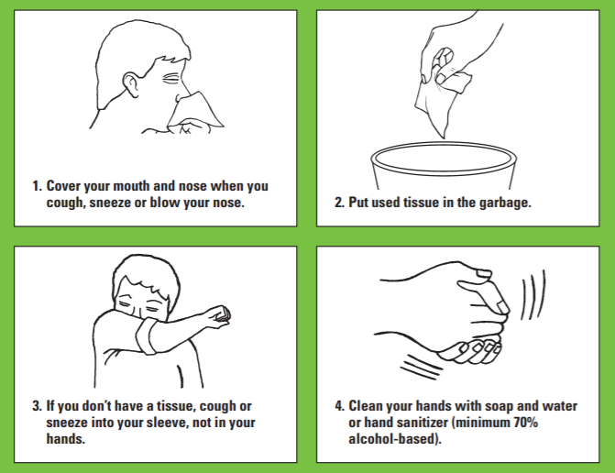

Read more about respiratory etiquette here (Source: Public Health Ontario)

Hand Hygiene
Hand hygiene is a general term referring to any action of hand cleaning and is a fundamental component of infection prevention and control. Touching your eyes, nose or mouth without cleaning your hands or sneezing or coughing into your hands may provide an opportunity for germs to get into your body. Keeping your hands clean through good hygiene practice is one of the most important steps to avoid getting sick and spreading germs to others.

- Handwashing with soap and running water, as opposed to using hand sanitizer, must be done when hands are visibly soiled. Hand hygiene with soap and water – done correctly – removes organisms.
- Hand sanitizers with 70-90% alcohol may be used when your hands are not visibly dirty. Hand hygiene with alcohol-based hand sanitizer – correctly applied – kills organisms in seconds.

All visitors must perform hand hygiene prior to beginning each visit with a resident and if at any time their hands become soiled during the visit. Wash or sanitize your hands at the end of the visit as well.
Follow these steps:
Video: How to Hand Wash

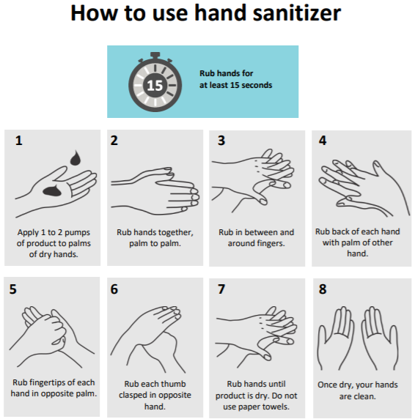
Read more about hand hygiene here (Source: Public Health Ontario)

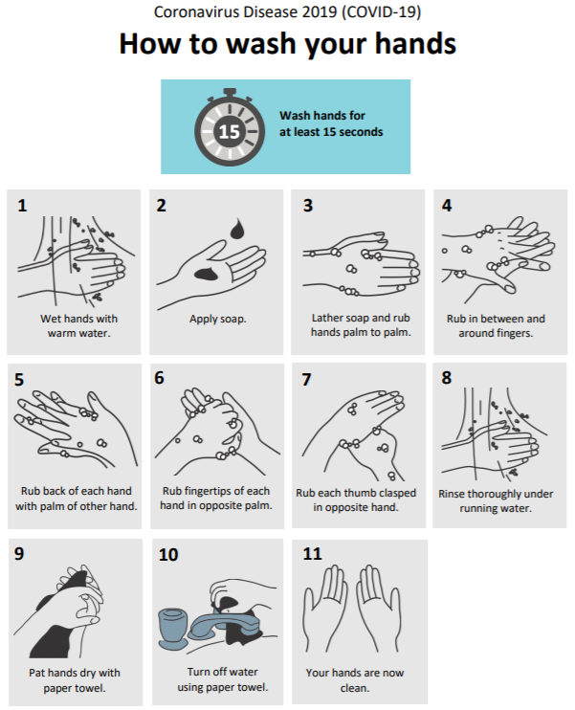

Proper PPE Etiquette

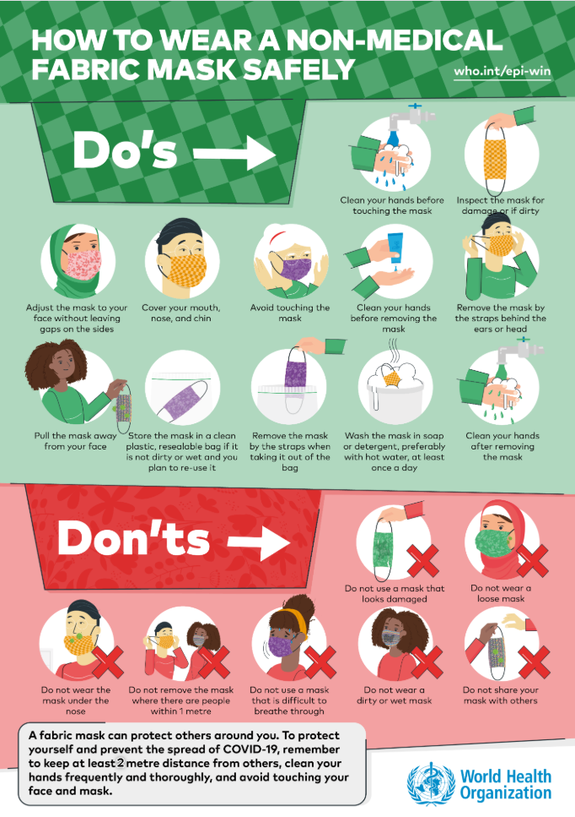

Source: World Health Organization (Non-Medical Fabric Mask)
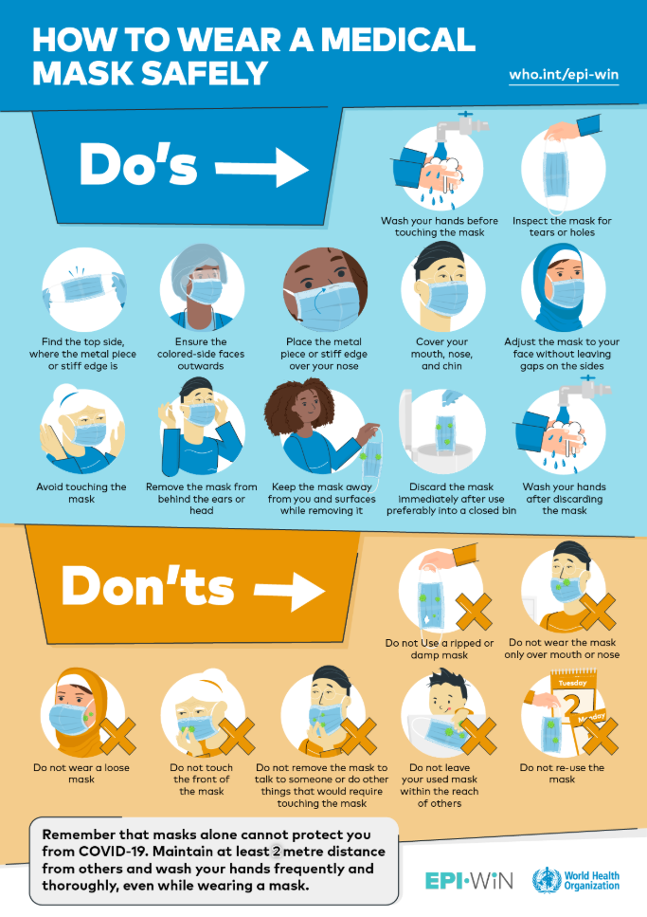

Source: World Health Organization (Medical Mask)

Discontinuation of Visits/Refusal of Entry
All visitors to the residence are expected to comply with the visiting policy. Failure to comply with the residence’s visiting policy may result in the discontinuation of visit(s) when risk of harm from continual non-compliance is considered too high. Refusal of entry will be assessed on a case-by-case basis by management/Designate.

Complaints Process
Should a visitor have a complaint about the administration of the residence’s visiting policy, they may contact Executive Director by phone at 416-284-0828 and the complaint will be responded to in a timely manner. If your concern is not resolved to your satisfaction with the residence’s management, visitors may contact the Ministry of Health and Long-Term Care (MOHLTC) by phone (1-866-434-0144); or the Retirement Homes Regulatory Authority (RHRA) by email (info@rhra.ca) and/or phone (1-855-275-7472).

Accessibility Considerations
The residence is required to meet all applicable laws such as the Accessibility for Ontarians with Disabilities Act, 2005.

